Guest or Tourist information centre

General

 | Survey name | Guest or Tourist information centre
 | Author | Richard Žižka
 | Language | English
 | Survey URL | http://www.survio.com/survey/d/Y9H0W3M7W6S7E4X5T
 | First response  Last response | 02/28/2014  03/03/2014
 | Duration | 4 days

Survey visits

120 | 20 | 33 | 67 | 16.67%
Total visits | Total completed | Total unfinished | Displayed only | Overall completion rate
Visit History (02/28/2014 - 03/03/2014)
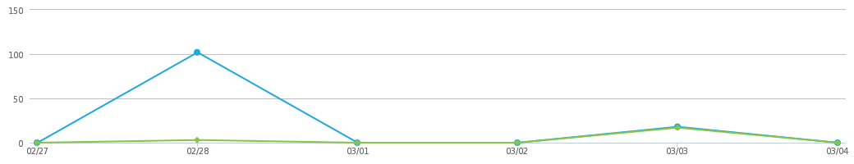
 | Total visits (120) |  | Total completed (20)

Total Hits | Visit Sources | Average Time of Completion
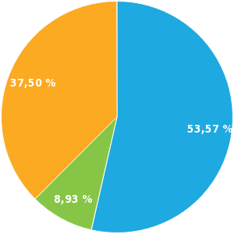 | 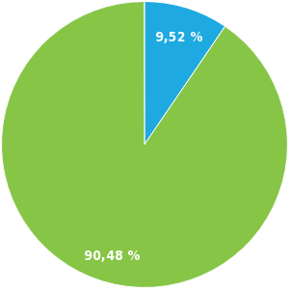 | 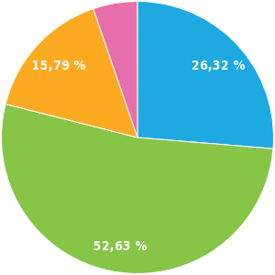
Displayed only (53.57%)  Unfinished (8.93%)  Completed (37.50%) | Direct link (9.52%)  E-mail invitation (90.48%) | <1 min. (26.32%)  1-2 min. (52.63%)  2-5 min. (15.79%)  10-30 min. (5.26%)

Results
1. How do you use the information centre?
Multiple choice, answers 20x, unanswered 0x
Answer | Answers | Ratio
As a citizen | 12 | 60.00%
As a tourist | 12 | 60.00%
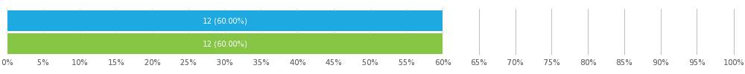
2. Please indicate your age group below:
Single choice, answers 20x, unanswered 0x
Answer | Answers | Ratio
0-20 | 3 | 15.00%
21-30 | 6 | 30.00%
31-40 | 3 | 15.00%
41-50 | 4 | 20.00%
51-60 | 2 | 10.00%
61+ | 2 | 10.00%
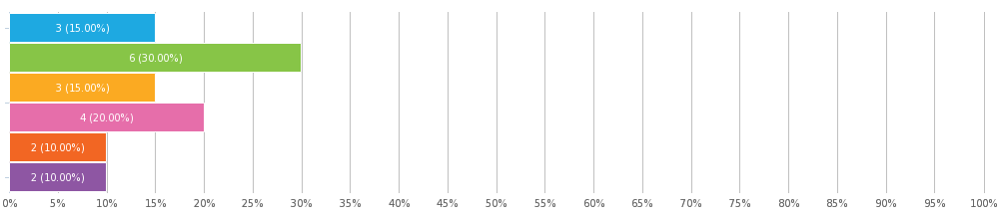

3. How often do you use the information centre?
Single choice, answers 20x, unanswered 0x
Answer | Answers | Ratio
More than once per month | 5 | 25.00%
Monthly | 9 | 45.00%
Yearly | 4 | 20.00%
Less often | 2 | 10.00%
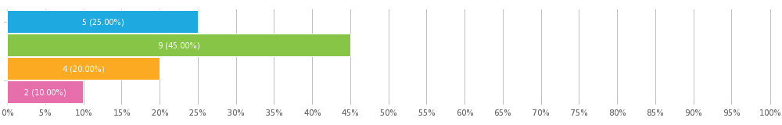
4. Why did you visit the information centre?
Multiple choice, answers 20x, unanswered 0x
Answer | Answers | Ratio
To find information on local travel and the region | 5 | 25.00%
To find information on cultural or social events in the region | 8 | 40.00%
To access the internet | 10 | 50.00%
To use a photocopier | 8 | 40.00%
To find brochures and souvenirs | 8 | 40.00%
To find a city tour with commentary | 5 | 25.00%
To purchase advanced travel or event tickets | 4 | 20.00%
Other (Please specify) | 2 | 10.00%
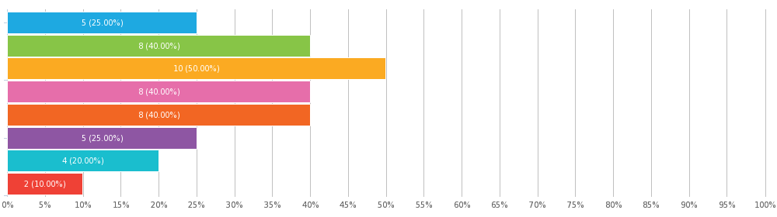

Duis aute irure dolor in reprehenderit in voluptate velit esse cillum
Nemo enim ipsam voluptatem, quia voluptas sit
5. How satisfied were you with the following services?
Matrix of single choices, answers 20x, unanswered 0x
 | Very satisfied | Satisfied | Indifferent | Dissatisfied | Very dissatisfied
The services on offer | 5 (25.00%) | 5 (25.00%) | 5 (25.00%) | 2 (10.00%) | 3 (15.00%)
The quality of the services provided | 4 (20.00%) | 5 (25.00%) | 7 (35.00%) | 3 (15.00%) | 1 (5.00%)
The internet connection speed/avalability | 2 (10.00%) | 9 (45.00%) | 5 (25.00%) | 3 (15.00%) | 1 (5.00%)
The access, comfort and hospitality | 5 (25.00%) | 3 (15.00%) | 7 (35.00%) | 5 (25.00%) | 0
The quality of service provided by the staff | 5 (25.00%) | 4 (20.00%) | 5 (25.00%) | 4 (20.00%) | 2 (10.00%)
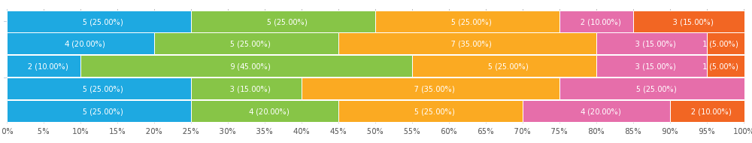
6. Did the information centre have what you needed?
Single choice, answers 20x, unanswered 0x
Answer | Answers | Ratio
Yes | 13 | 65.00%
No | 7 | 35.00%
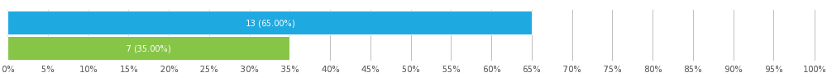
7. Have you ever visited the information centre website?
Single choice, answers 20x, unanswered 0x
Answer | Answers | Ratio
Yes | 14 | 70.00%
No | 6 | 30.00%
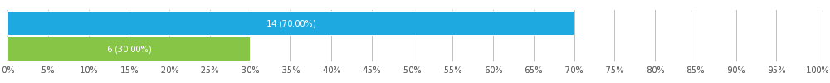
8. Did you find everything you were looking for on our website?
Single choice, answers 20x, unanswered 0x
Answer | Answers | Ratio
Yes | 17 | 85.00%
No (Please let us know what you were looking for) | 3 | 15.00%
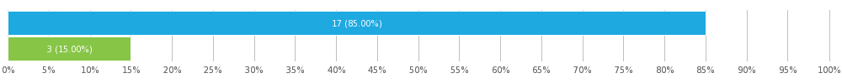

Aenean laoreet
esse cillum dolore eu fugiat
voluptatem, quia voluptas sit
9. Would you say that the information centre was useful or important to your visit?
Single choice, answers 20x, unanswered 0x
Answer | Answers | Ratio
Yes | 16 | 80.00%
No (Please state briefly why this is not the case) | 4 | 20.00%
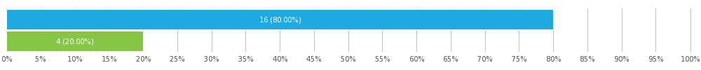

Ut enim ad minim veniam
commodo consequat
Itaque earum rerum hic
necessitatibus saepe eveniet

10. How would you rate the overall level and quality of the services provided by the information centre?
Star Rating, answers 20x, unanswered 0x
Number of stars 6/10
Answer | Answers | Ratio
10/10 | 2 | 10.00%
9/10 | 2 | 10.00%
8/10 | 3 | 15.00%
7/10 | 2 | 10.00%
6/10 | 3 | 15.00%
5/10 | 2 | 10.00%
4/10 | 2 | 10.00%
3/10 | 1 | 5.00%
2/10 | 2 | 10.00%
1/10 | 1 | 5.00%
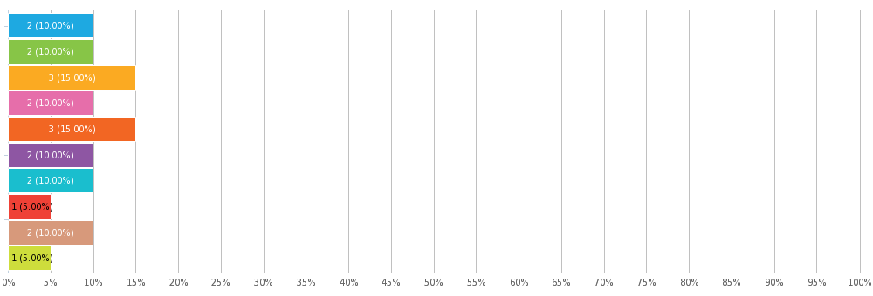
11. Do you have any suggestions or comments on how we can improve your next visit?
Text answer, answers 20x, unanswered 0x
Morbi tempor justo velit, vitae suscipit eros eleifend sit amet. Fusce imperdiet tellus quis sodales facilisis.

Lorem ipsum dolor sit amet, consectetur adipisicing elit, sed do eiusmod tempor incididunt ut labore et dolore magna aliqua. Ut enim ad minim veniam, quis nostrud exercitation ullamco laboris nisi ut aliquip ex ea commodo consequat.

haleluja

Lorem ipsum dolor sit amet, consectetur adipisicing elit, sed do eiusmod tempor incididunt ut labore et dolore magna aliqua.

Ut enim ad minim veniam, quis nostrud exercitation ullamco laboris nisi ut aliquip ex ea commodo consequat.

Duis aute irure dolor in reprehenderit in voluptate velit esse cillum dolore eu fugiat nulla pariatur.

Excepteur sint occaecat cupidatat non proident, sunt in culpa qui officia deserunt mollit anim id est laborum.

voluptatem accusantium doloremque laudantium, totam rem aperiam eaque ipsa

quae ab illo inventore veritatis et quasi architecto beatae vitae dicta sunt, explicabo

Nemo enim ipsam voluptatem, quia voluptas sit, aspernatur aut odit aut fugit

sed quia consequuntur magni dolores eos, qui ratione voluptatem sequi nesciunt, neque

qui blanditiis praesentium voluptatum deleniti atque corrupti, quos dolores et

qui officia deserunt mollitia animi, id est laborum et dolorum fuga

facere possimus, omnis voluptas assumenda est, omnis dolor repellendus

sint et molestiae non recusandae. Itaque earum rerum hic tenetur a sapiente delectus

sunt in culpa, qui officia deserunt mollitia animi, id est laborum et dolorum fuga

quis nostrum exercitationem ullam corporis suscipit laboriosam

Et harum quidem rerum facilis est et expedita distinctio. Nam libero tempore

debitis aut rerum necessitatibus saepe eveniet, ut et voluptates repudiandae

rerum necessitatibus saepe eveniet, ut et voluptates repudiandae sint et molestiae non rec

Survey settings

 | Questions per page | Multiple
 | Allow multiple submissions?
 | Allow return to previous questions?
 | Display question numbers?
 | Randomise question order?
 | Show progress bar?
 | Receive response notifications by email?
 | Password protection?
 | IP restriction?

Appendix: Survey
Guest or Tourist information centre
Hello,
Please take a few minutes of your time to fill in the following survey.
1. How do you use the information centre?
As a citizen
As a tourist
2. Please indicate your age group below:
0-20
21-30
31-40
41-50
51-60
61+
3. How often do you use the information centre?
More than once per month
Monthly
Yearly
Less often
4. Why did you visit the information centre?
To find information on local travel and the region
To find information on cultural or social events in the region
To access the internet
To use a photocopier
To find brochures and souvenirs
To find a city tour with commentary
To purchase advanced travel or event tickets
Other (Please specify)
5. How satisfied were you with the following services?
 | Very satisfied | Satisfied | Indifferent | Dissatisfied | Very dissatisfied
The services on offer
The quality of the services provided
The internet connection speed/avalability
The access, comfort and hospitality
The quality of service provided by the staff
6. Did the information centre have what you needed?
Yes
No
7. Have you ever visited the information centre website?
Yes
No
8. Did you find everything you were looking for on our website?
Yes
No (Please let us know what you were looking for)
9. Would you say that the information centre was useful or important to your visit?
Yes
No (Please state briefly why this is not the case)

10. How would you rate the overall level and quality of the services provided by the information centre?
/ 10
11. Do you have any suggestions or comments on how we can improve your next visit?

